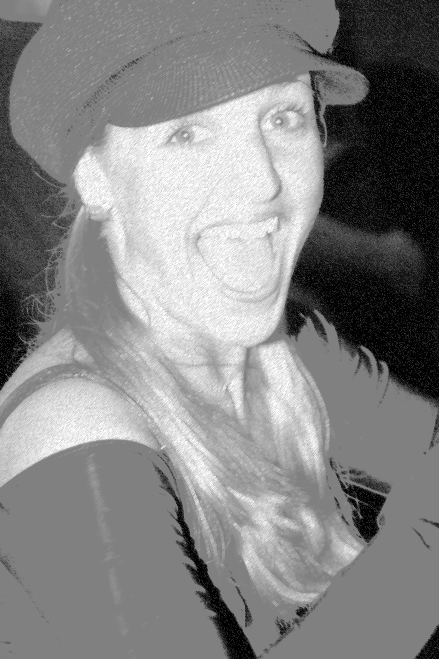
Salsara is Back!
Time: 10am-12pm
Date: 23 July
Price: £10 (2 hrs.)
Don´t miss this unique opportunity to take a specially designed workshop with Salsara, the creator of the only known ladies' styling syllabus in the UK!

The two-hour workshop is an abridged version of her unique ladies styling courses run last year with Simone. The workshop will cover technique and basic styling in the first hour, building up to advanced styling and body movement in the second hour. Students will learn spinning technique, ladies' shines, musical interpretation, styling, body movement, facial expression, advanced styling and much more ...
Drill Hall
16 Chenies Street
London WC1E 7EX
www.drillhall.co.uk

Contact person: salsarauk@yahoo.com

07775 876 599

